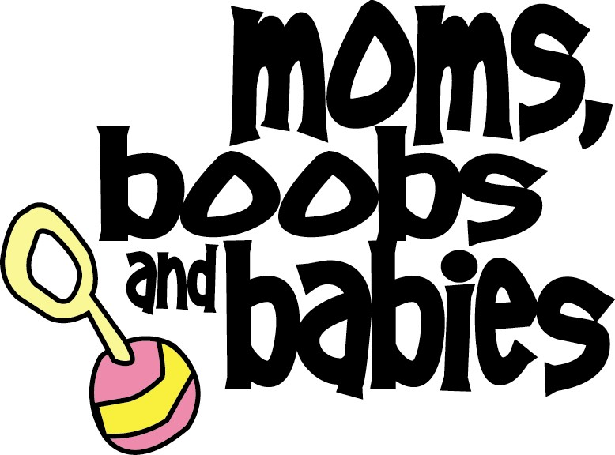
Photo Release Form

Name(s): _______________________________________________________

Address: _______________________________________________________

Phone Number: __________________________________________________

- I, ___________________________________________________________, hereby consent to the use, reproduction and publication of photographs (or other specified media record) submitted to Moms, Boobs and Babies (Yellowknife`s Breastfeeding Support Group).
- I understand that by signing this form, I acknowledge Moms, Boobs and Babies has asked for, and received my permission to use this photo taken by me or of me on their website and documents and promotional materials in various media. Such photo may be reproduced electronically, alone or in composites.
- I understand that any use of the photo on a website will be accessible to anyone with Internet access, and on the MBB Breastfeeding Support Facebook group will be accessible to everyone who is a member of that group. I also understand that prior to posting photos, a copyright notice prohibiting the copying of material without Moms, Boobs and Babies’ written authorization will be posted on the website and Facebook Group. I understand that Moms, Boobs and Babies is not responsible for and have no control over what other parties might do with these representations once published.
- I have read this release carefully. I understand its contents and I agree with its terms. I understand that by signing this consent form, I am waiving any legal rights I may have to the photographs/video. I am also consenting to the release of my name and hometown for the purposes of identifying me and my child.
Signature: _______________________________________________

Date: ___________________________________________________

IMPORTANT: If you are under 18 years of age, please have your parent or legal guardian read this document and complete the portion below, if they agree to its terms:

Name of Parent/Legal Guardian: ________________________________________________

Phone Number: _________________________________________

Signature: ______________________________________________

Date: __________________________________________________

Moms, Boobs and Babies is committed to respecting your privacy and protecting your personal information. You have the right to revoke consent at any time by contacting us at info@momsboobsandbabies.com or by calling 444-3374. Please don’t hesitate to contact us if you have any questions.

